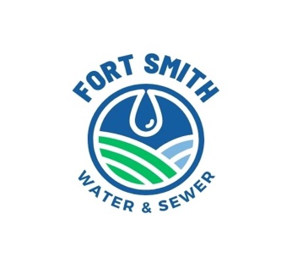
FORT SMITH WATER & SEWER DISTRICT
MONTHLY BOARD MEETING
Friday, November 21, 2025 @ 9:00 AM (Mountain time)
Meeting To Be Held at the Bighorn Baptist Church
Located At: 11 1ST STREET EAST
Call in information to attend via phone conference
Phone #: 267-930-4000
Access code: 259 831 177#
To attend via Teams:
https://teams.live.com/meet/9345953821735?p=E2dnah3iVmgHt6Yxln
Meeting ID: 934 595 382 173 5
Passcode: Qb7Lc3
Agenda:
- Opening – Roll Call
- Approval of October 23, 2025 Meeting Minutes
- Financial Report/Bills/Past Due Accounts/Audit
- Rate Increase
- Old Business:
- Wastewater Project:
- Drawdowns
- Aerator Repair/Maintenance
- Newterra regarding leaving or pulling aerators in cold months
- Fencing Repair at Lagoon
- Operator Report
i Eye on Water Installs
- Power Security
- Peak Demand Charge Issue
- Communication Repeater for Bus System
- Conference Camera for meetings
- PFAS sampling
- Cyber Security Issues and Plans
- New Business
- November meeting date:
- Public Comments
- Adjourn Meeting

